Module 02: Assignment - Basic Programming Modules – Python

Name: Judith Barrios

Course: 2277 - Module 02 Basic Programming Modules

Date: 09/04/25

1. This program writes a list of cities to a file, appends another city, reads all lines into a list, and checks if the file exists.

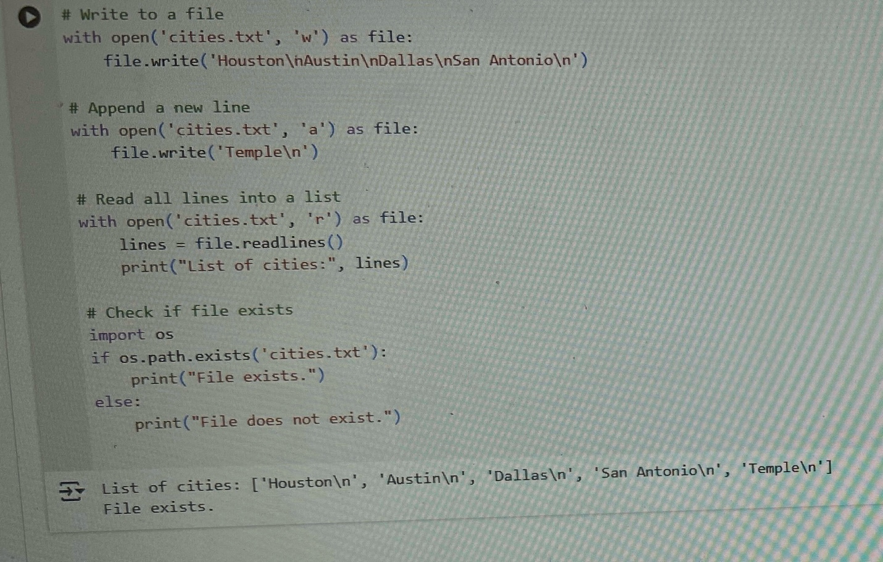

1. This program creates a personalized welcome message using f—string formatting and then applies string methods to transform, analyze, and evaluate the message.
2. 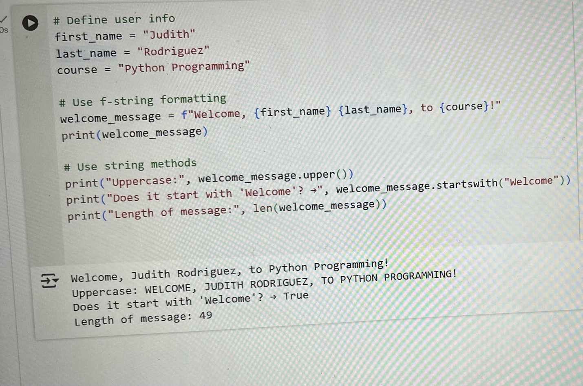This code shows how to run multiple tasks concurrently using pythons asyncio module, allowing functions to execute simultaneously and improve efficiency when waiting on delays.

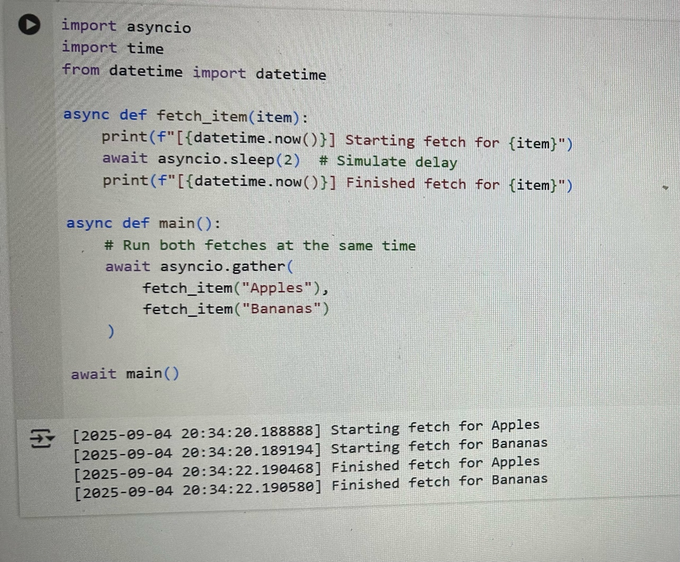

1. 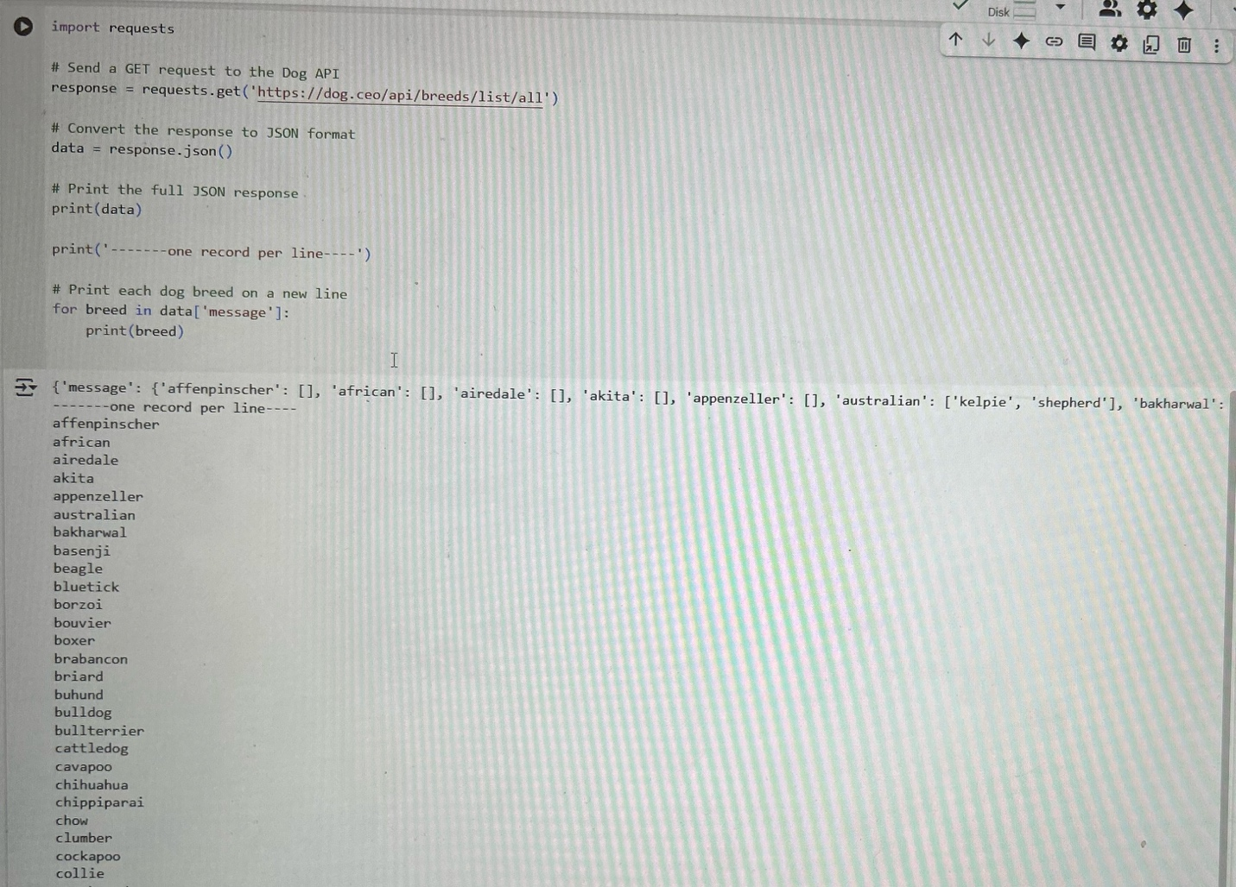This code sends a GET request to an API that returns a list of dog breeds, converts the response to JSON, and prints each breed name on a separate line.
2. This one creates an in-memory SQLite database, adds two employee records, updates one salary, removes one record, and prints the remaining data, all within Colab, no external setup needed.

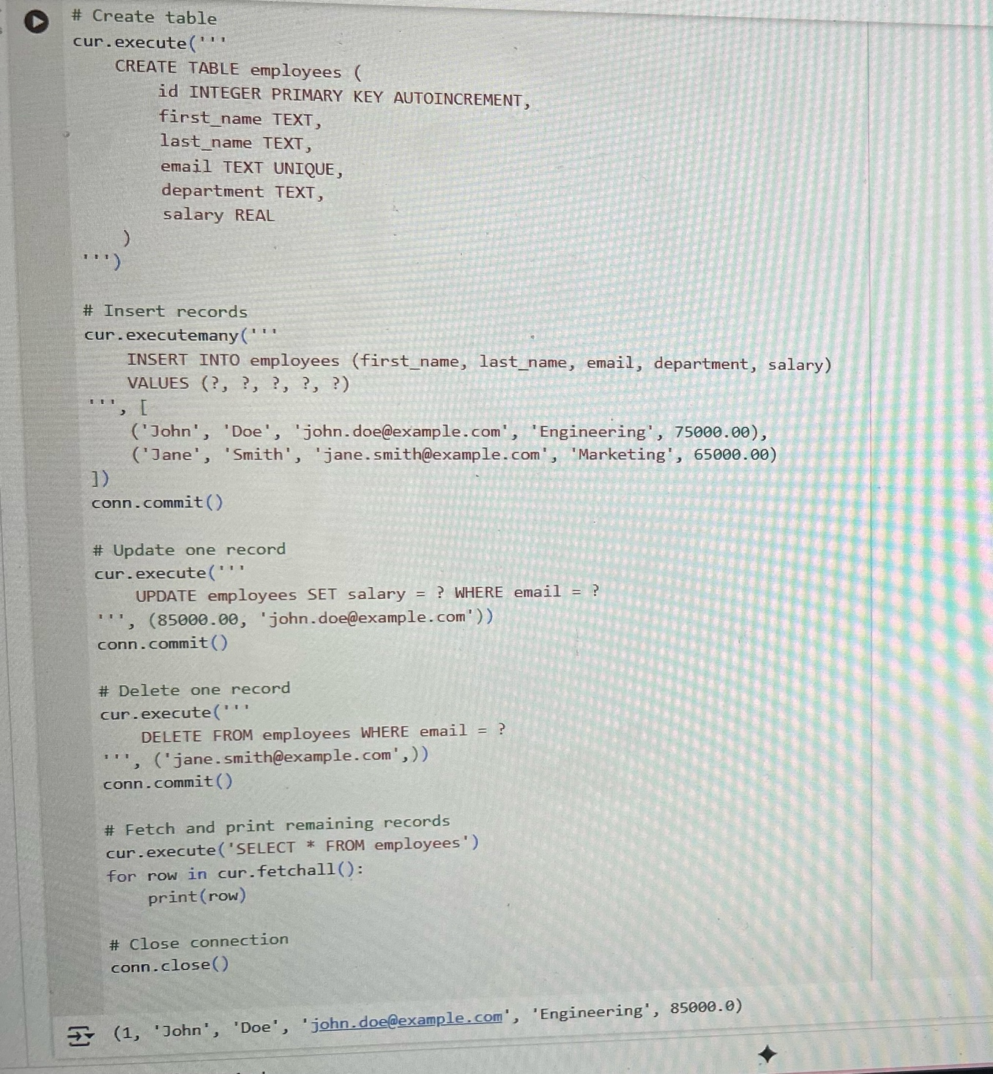

1. This program creates two NumPy arrays and performs element-wise addition, subtraction, multiplication, and a dot product to show basic array math.

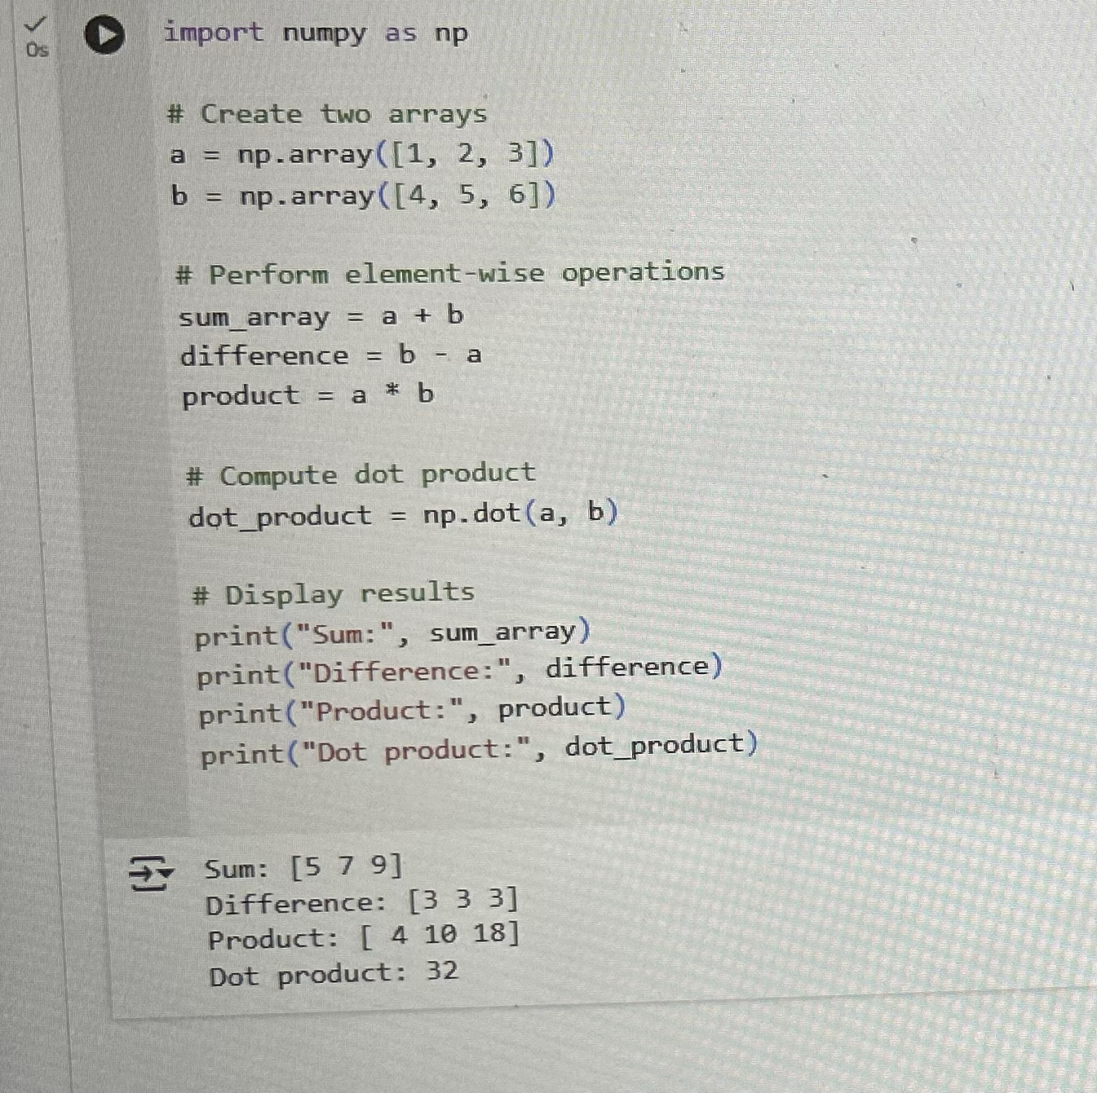

1. The last one has a DataFrame of elements, filters for rows where the category is “Gas”, saves the full DataFrame to a CSV file, and reads it back to confirm the data was stored correctly.

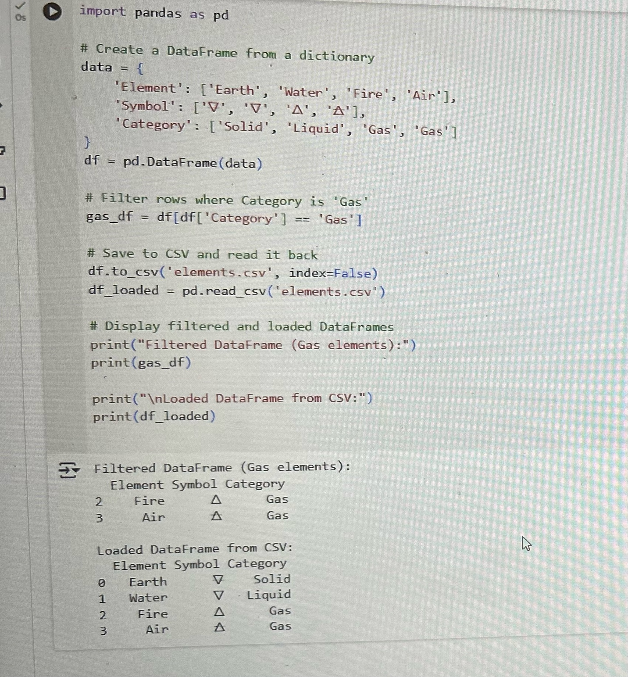

Conclusion: This collection of tutorials demonstrates foundational Python skills, from file handling and string manipulation to async programming, HTTP requests, database operations, and data analysis, equipping you with versatile tools for real world coding.